Left Join

Definition
# Source: AI Source: Provided by: [Data Path: Persons Table -> ID Column: 1, Name_En Column: Motasem Essam] -> From: [Chatgpt (GPT‑5 Mini)] on [12/10/2025]
A Left Join or Left Outer Join is a data operation that combines two datasets while keeping all rows from the left table and adding the matching rows from the right table based on a common key. If there is no match in the right table, the result contains null/NaN values for the right-side columns.

Key Idea
# Source: AI Source: Provided by: [Data Path: Persons Table -> ID Column: 1, Name_En Column: Motasem Essam] -> From: [Chatgpt (GPT‑5 Mini)] on [12/10/2025]
A Left Join preserves every record from the left dataset, even if there is no corresponding record in the right dataset.

How It Works
# Source: AI Source: Provided by: [Data Path: Persons Table -> ID Column: 1, Name_En Column: Motasem Essam] -> From: [Chatgpt (GPT‑5 Mini)] on [12/10/2025]
- Select the left table (primary dataset).
- Select the right table to join with it.
- Match rows using a common key column.
- If a match exists → combine the rows.
- If no match exists → keep the left row and fill right columns with null/NaN.

Example
# Source: AI Source: Provided by: [Data Path: Persons Table -> ID Column: 1, Name_En Column: Motasem Essam] -> From: [Chatgpt (GPT‑5 Mini)] on [12/10/2025]
Dataset A – Customers (Left Table)
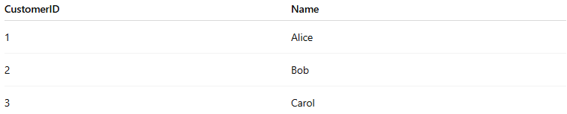
CustomerID | Name
1 | Alice
2 | Bob
3 | Carol
Dataset B – Orders (Right Table)
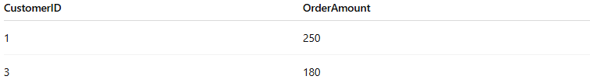
CustomerID | OrderAmount
1 | 250
3 | 180
Left Join on CustomerID
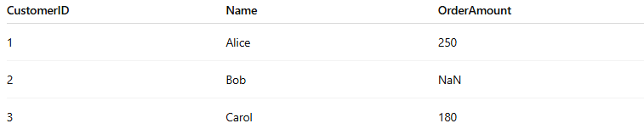
CustomerID | Name | OrderAmount
1 | Alice | 250
2 | Bob | NaN
3 | Carol | 180
- Customer 2 remains even though they have no order.
- Missing values from the right table appear as NaN (or NULL).

Applications
# Source: AI Source: Provided by: [Data Path: Persons Table -> ID Column: 1, Name_En Column: Motasem Essam] -> From: [Chatgpt (GPT‑5 Mini)] on [12/10/2025]
- Listing all customers even if they have no orders
- Combining main datasets with optional information
- Data preparation for analysis and reporting

Advantages
# Source: AI Source: Provided by: [Data Path: Persons Table -> ID Column: 1, Name_En Column: Motasem Essam] -> From: [Chatgpt (GPT‑5 Mini)] on [12/10/2025]
- Keeps all records from the main (left) dataset
- Useful when the left table is the primary data source
- Helps identify missing relationships between datasets

Disadvantages
# Source: AI Source: Provided by: [Data Path: Persons Table -> ID Column: 1, Name_En Column: Motasem Essam] -> From: [Chatgpt (GPT‑5 Mini)] on [12/10/2025]
- May introduce null/NaN values
- Can create larger datasets if the left table is large

